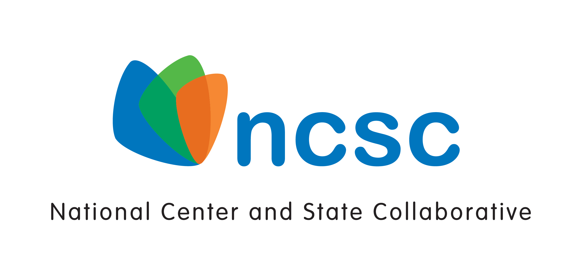
National Center and State Collaborative GSEG Project
NCSC Assessment Technology System
RFP # 2013-03-01

Intent to Bid Form
Please complete the form below and email to robin.taylor@zittels.com if your organization intends to submit a response to the above Request for Proposal. The deadline for submitting this Intent to Bid Form is April 10, 2013.
Vendor Name
Address
City, State, Zip
Name of Person Completing Form
Title
Signature
Date

This work is supported by a grant from the US Department of Education, Office of Special Education Programs (H373X100002, Project Officer: Susan.Weigert@ed.gov). The contents do not necessarily represent the policy of the US Department of Education, and no assumption of endorsement by the Federal government should be made.

